Brand identity package for a fictional company called “**game gear essentials”**:

**Objective**: Develop a complete brand identity package for game gear essential, a company that offers player friendly essentials to make them comfortable.

**Description:** Create a cohesive set of visual elements that define game gear essentials identity, including logos, color palettes, typography, and brand guidelines.

**Mission**: To make Gaming easy and comfortable the player by increasing the comfort for the player.

**Values:** Player friendly, innovation, simplicity, and community involvement.

**Target audience:** Gaming conscious individuals, businesses, and organizations.

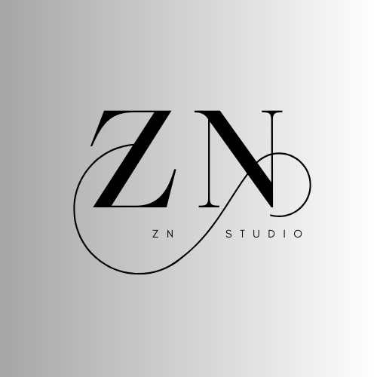 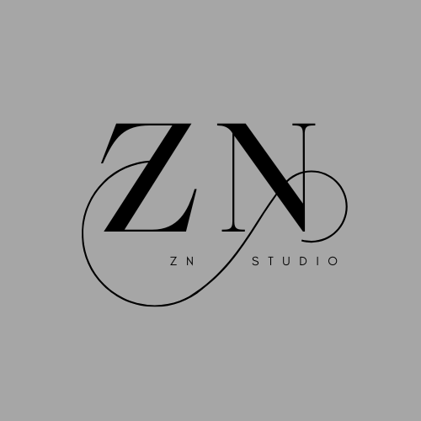

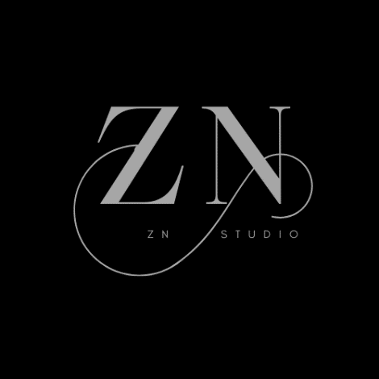 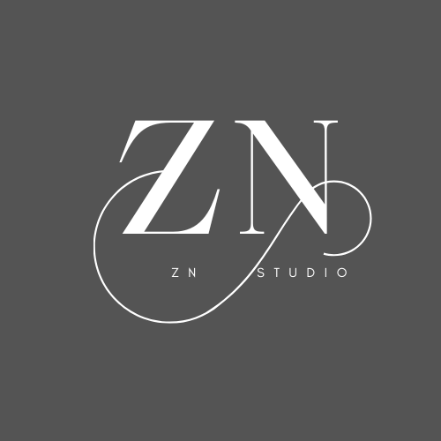

**Final version of LOGO:**



**Logo concept:**

* Stylized letters ZN shows my name.
* The infinity symbol indicates the passion for my work.
* A simple and modern word mark with infinity sign integrated into typography

**Final logo:**

The letter ”ZN” shows my name with vibrant colors and infinity sign to show the passion and comfort of users.

**Color palette:**

- Primary color: black

- Secondary color: grey

- Accent color: Black and grey)

- Background color: White or light gray or black or dark grey

**Typography:**

- Font family: Maharlika

- Font sizes:

- Headings: 130-132

- Body text: 11-12

- Line height: 1.5-2 times the font size

**Color Palette:**

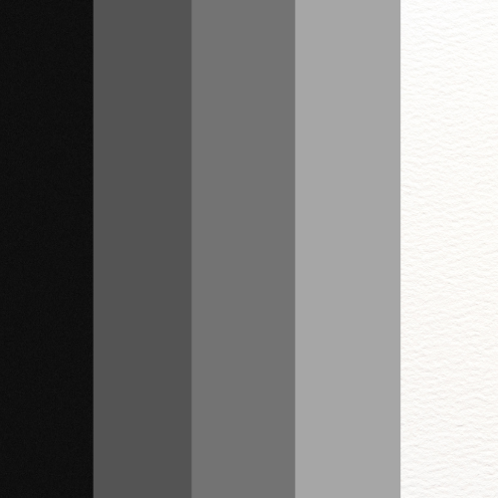

Letter page:

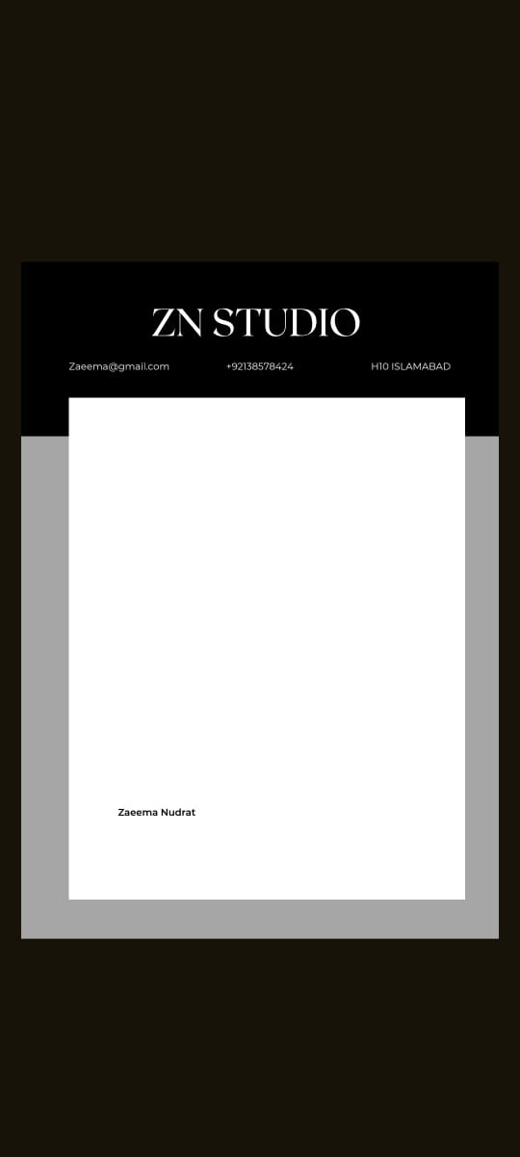

Business Card:

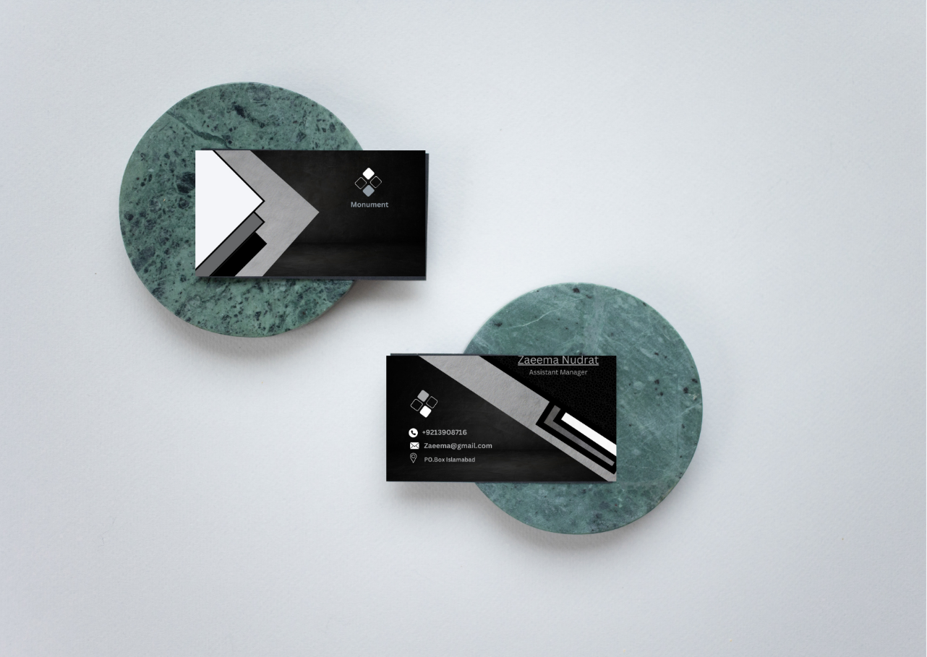

**Logo usage guideline:**

 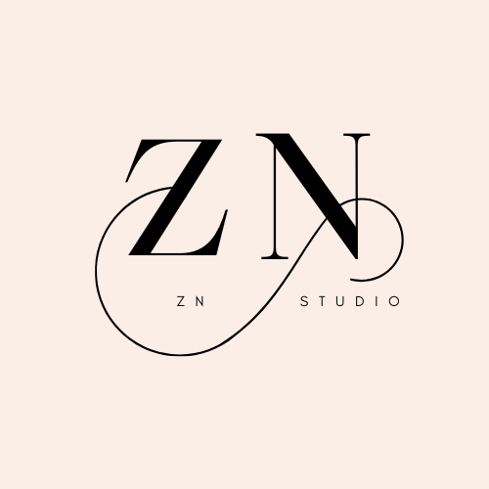

**RIGHT WRONG**

**This brand identity provides a comprehensive foundation for player with high gaming skills ensuring consistency and recognition across all marketing naturals.**